**TEAM-MIND’S EYE**

Yash Shukla

Vandana Mall

REX-FIT

# PROJECT OVERVIEW

Good health is not something we can buy. However, it can be an extremely valuable savings account, and REX-FIT is a step for opening that saving account.

It will keep a record of your steps, calories, water intake, will help to find the proper diet to lose weight, will have a reminder for medicine intake, will have yoga sessions that keep you fit, for an emergency will show nearby clinics or hospitals and also comes with features like Daily Exercise Routines and Personalised Diet Plan which will be connected and handle by Gyms/Dietician.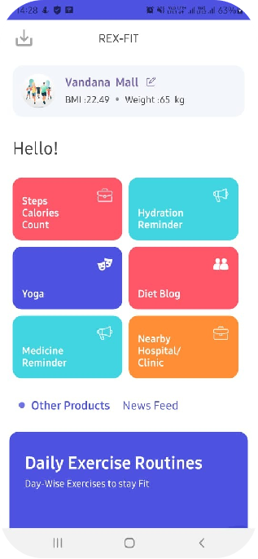

## FEATURES

* Step & Calories Counter
* Hydration Reminder
* Medicine Reminder
* Nearby Clinics/ Hospitals
* Diet Blog
* Yoga Session
* Daily Exercise Routines
* Personalized Diet Plan

### STEP & CALORIES COUNTER

These features will keep track of your steps and calories and will display the day, the weekly and monthly graph for the track, and also set daily targets.

### HYDRATION REMINDER

This feature will remind the user to drink water and keep track of daily water intake and will set daily targets according to the weight of a person.

### YOGA

This feature will provide daily yoga sessions with the timer set for each yoga with the picture of the pose.

### DIET BLOG

This feature will help the user to have a piece of proper knowledge about how to maintain a healthy diet plan.

### MEDICINE REMINDER

This feature will remind the user to take their medicine on time.

### NEARBY HOSPITALS/CLINICS

This feature will display all the hospitals or clinics nearby and in an emergency will make a call in hospitals.

### DAILY EXERCISE ROUTINE

This will be connected with a trainer or a gym and will have online workout sessions on a daily basis according to the user requirement and will act just like a personal trainer.

### PERSONALISED DIET PLAN

In this feature, the user will have to fill a question-answer form, and then it will proceed to a dietician for making a proper diet plan according to the answers given by the user, and then the user will receive their diet plan which will change on monthly basis according to their BMI and requirements.

## Project Directory Contents

* [.idea](https://github.com/vandanamall/Health/tree/master/.idea)
* [App](https://github.com/vandanamall/Health/tree/master/app)
* [gradle/wrapper](https://github.com/vandanamall/Health/tree/master/gradle/wrapper)
* [.gitignore](https://github.com/vandanamall/Health/blob/master/.gitignore)
* [Build.gradle](https://github.com/vandanamall/Health/blob/master/build.gradle)
* [Gradle.properties](https://github.com/vandanamall/Health/blob/master/gradle.properties)
* [Gradlew](https://github.com/vandanamall/Health/blob/master/gradlew)
* [Gradlew.bat](https://github.com/vandanamall/Health/blob/master/gradlew.bat)
* [settings.gradle](https://github.com/vandanamall/Health/blob/master/settings.gradle)

Ways to host your project on the localhost

* Link to .apk file - https://drive.google.com/file/d/1vST6eBDW94Kz-dYSo9XY_3R24uOgt8si/view?usp=sharing
* Download and Install the apk file on any Android Smartphone.
* Login/SignUp through Firebase Verification.

(Sample Login Credentials : Phone - 9918187538 , pass - 12345678)

* Use the Application.